TASK | Cleaning paintwork to a shiny finish
LOCATION OF USE | Workshop |  | Assessment  No |  | 025
PRODUCT NAME | Color Magic Plus
DESCRIPTION OF SUBSTANCE | Polish and wax blend. Surface finishing medium
MANUFACTURER | Turtle Wax
MANUFACTURERS CONTACT | East Gillibrands  Skelmersdale  Lancashire  England  WN8 9TX  Tel: +44 (0)1695 722 161  Fax: +44 (0)1695 716 621
ASSESSOR | Martin Monaghan CMIOSH |  | Date |  | 04 12 25
TITLE | Health and Safety Consultant |  | Review by |  | 04 12 27
Personnel Performing Task  (Please list below)  Technicians/ Fitters/ Workshop Operatives |  | Time Spent  (Minutes/day)  As and when required, amounting to a few minutes per day | Training Given 
 |  |  | Yes

MSDS Revision Date | Hazard Statement
01/03/2014

Assessment to be conducted in Association with Hazard Data Sheets, a full current copy of which must be attached to this assessment.

Please denote the hazardous properties of the substances used in the task with a 

NEW INTERNATIONAL GLOBALLY HARMONISED HAZARD SYMBOLS
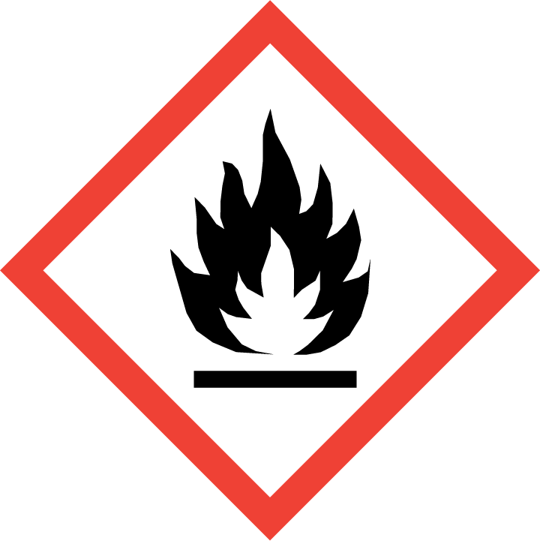 | 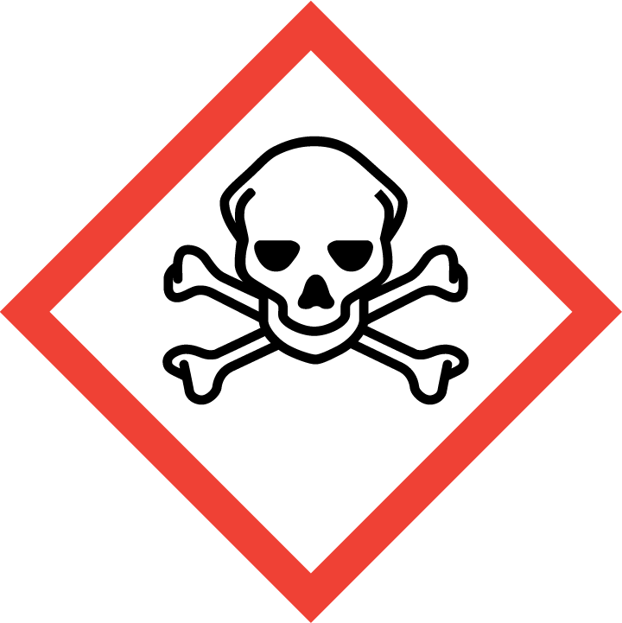 | 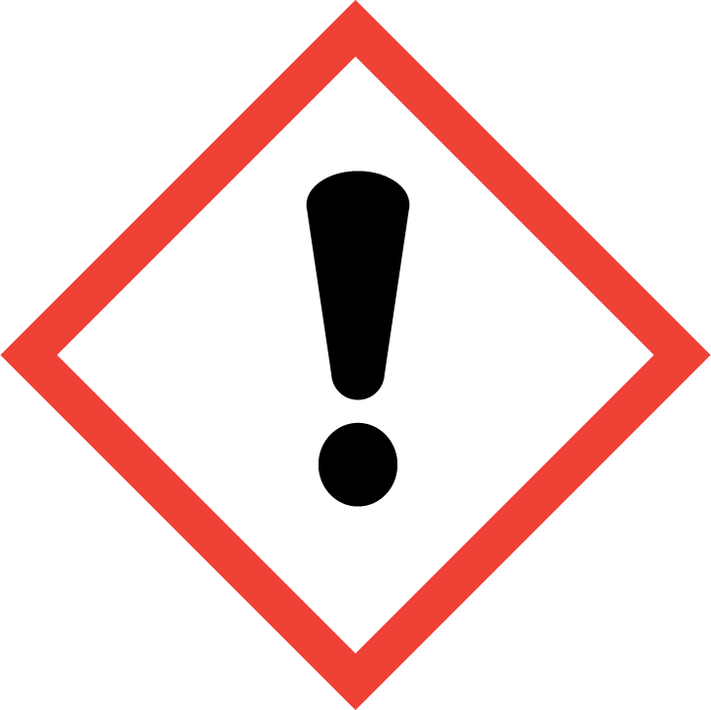 | 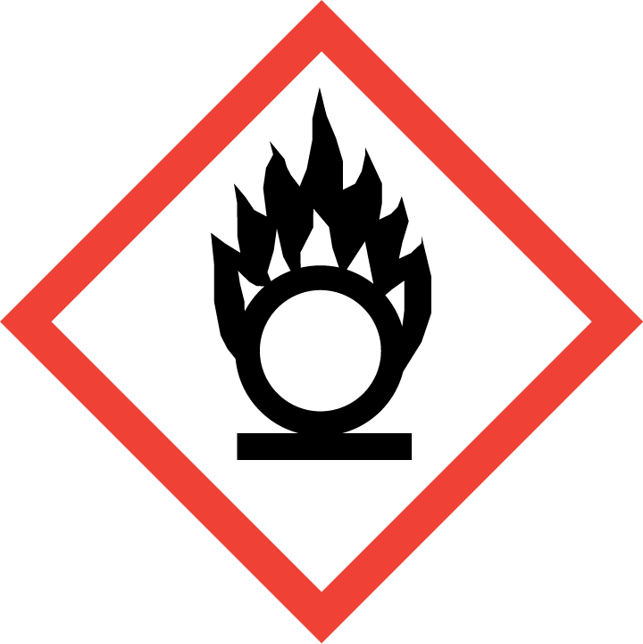 | 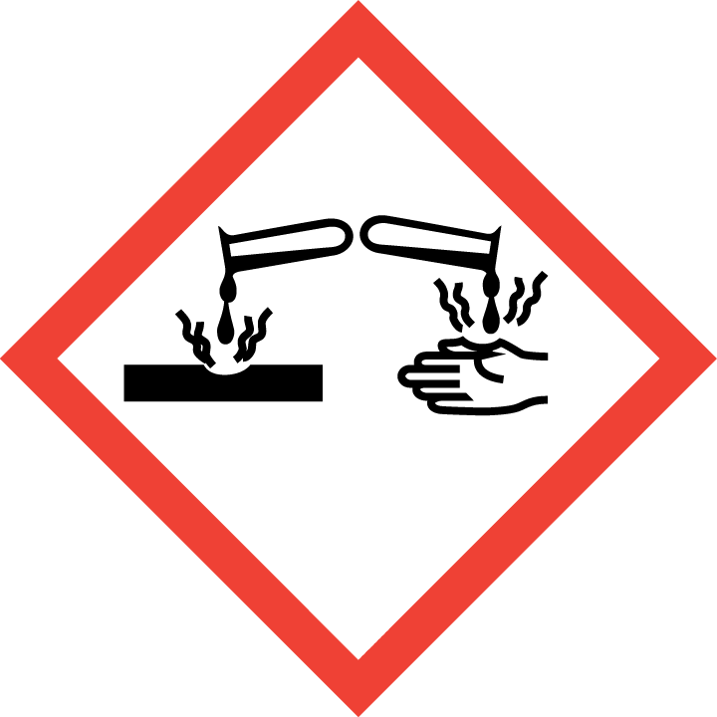 | 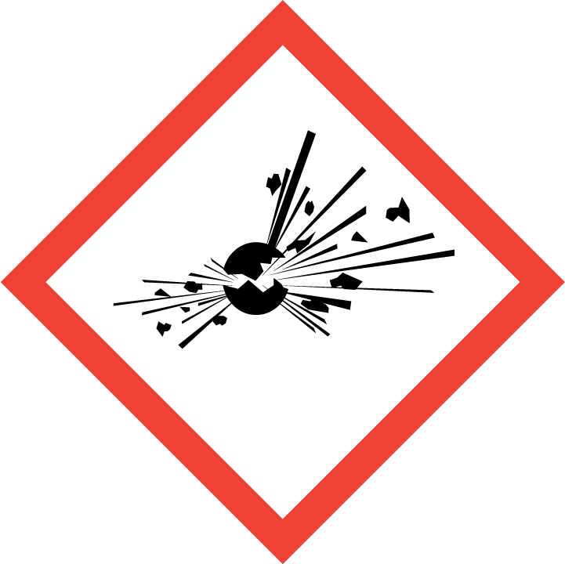 | 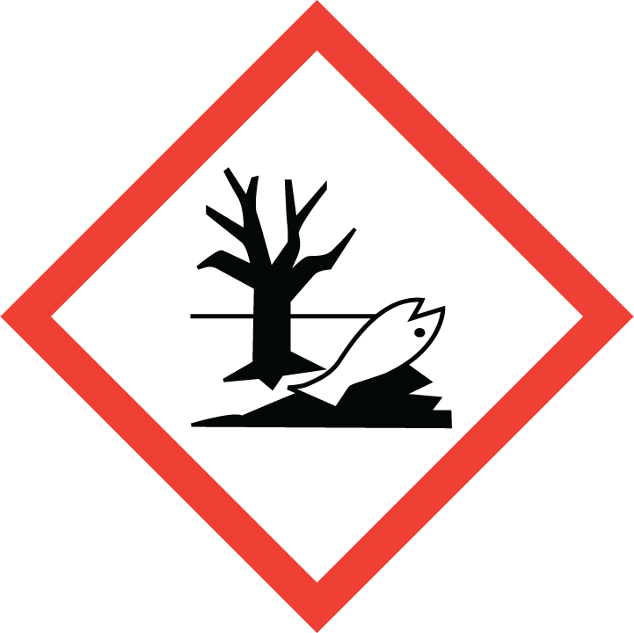 | 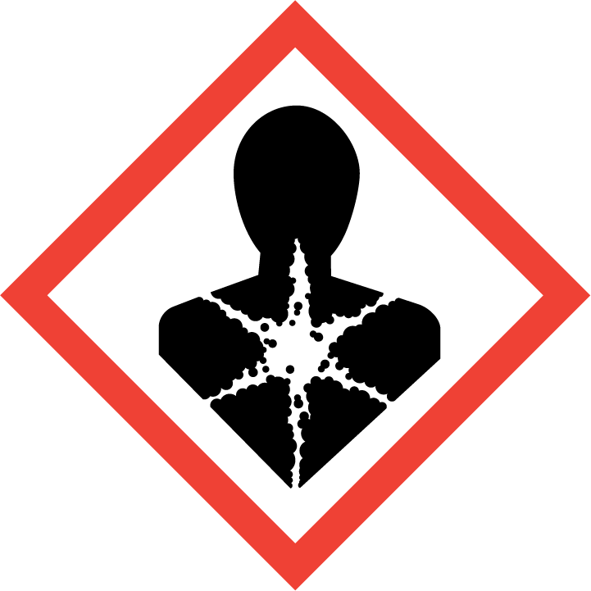
Flammable | Toxic | Harmful | Oxidising | Corrosive | Explosive | Harmful to the environment | Health Hazards i.e. respiratory sensitisation or carcinogenicity
 |  |  |  |  |  |  | 

SMOKING, EATING AND DRINKING ARE PROHIBITED IN THE WORK AREAS.
Information, Instruction and Training must be provided to all users. Young Persons, New or Expectant Mothers and other vulnerable groups must not use or be exposed to this product.

WORKPLACE EXPOSURE LIMITS (WEL’s)
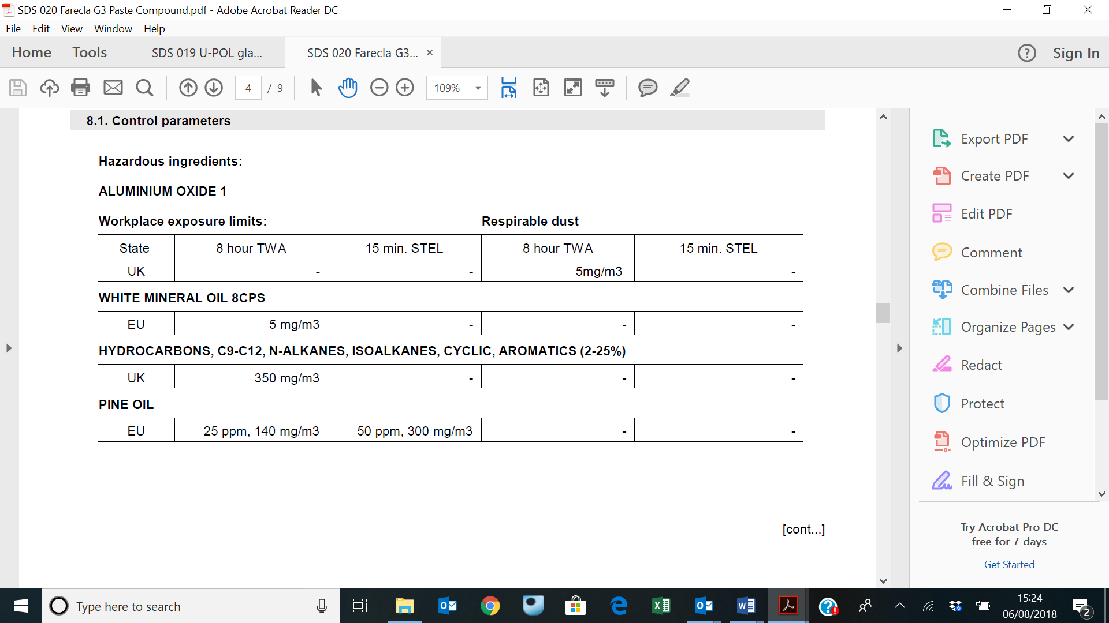

IMPORTANT!
Refer to Workplace Exposure Levels information provided in the Manufacturers Safety Data and revise control measures if exposure levels likely to be reached.

ROUTE OF EXPOSURE
Skin |  | Eyes |  | Inhalation | 
Ingestion |  | Cuts/abrasions |  | Systemic

PERSONS AT RISK
User of product |  | Co workers |  | Members of the public

ROUTE OF EXPOSURE |   FIRST AID MEASURES
Eyes | Bathe the eye with running water for 15 minutes.
Skin | Remove all contaminated clothes and footwear immediately unless stuck to skin. Wash immediately with plenty of soap and water. Consult a doctor
Inhalation | Remove casualty from exposure ensuring one’s own safety whilst doing so. Consult a doctor.
Ingestion | Wash out mouth with water. Consult a doctor
In all cases of doubt, or if symptoms persist seek medical attention. Never give anything by mouth to an unconscious person. If unconscious, place in recovery position and seek medical advice.

PERSONAL PROTECTIVE EQUIPMENT
 |  |  |  | 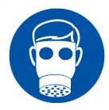 |  | 
YES | YES | YES/NO |  | YES/NO | YES | YES/NO
 |  |  |  |  | 
YES | YES |  |  |  | YES

HANDLING | STORAGE | TRANSPORT | DISPOSAL
Avoid contact with skin and eyes. Do not swallow. Do not eat, drink or smoke while handling. Wash hands with soap and water after handling. Launder all clothing before re-use. | Keep container tightly closed. Store in a well ventilated place. Do not store above 49°C (120°F). | This product does not require a classification for transport. | Dispose of packaging with an appropriate licensed waste service

REQUIRED CONTROL MEASURES
- Users to avoid contact with skin and eyes– Use PPE.
- Only opened solvent containers should be kept at the bench.
- When not in use, opened solvent containers should be kept in the flammables cupboards, under the work benches.
- Wash contaminated clothing before reuse. Wash hands after contact. When using, do not eat, drink or smoke.
- Ensure adequate welfare and washing facilities available and provide users with barrier and restorative creams. Take good hygiene measures.
- Ensure operatives are made aware of and understand the purpose of this assessment and MSDS, plus any health implications of using the product.
- Ensure COSHH assessments with accompanying MSDS are made available for all employees and users and for inspection and emergency purpose.
- Wash promptly if skin becomes contaminated. Wash hands at the end of each work shift and before eating, smoking and using the toilet.

FIRE PRECAUTIONS
EXTINGUISHING MEDIA
Water spray, carbon dioxide, dry chemical, and alcohol foam.

ACCIDENTAL RELEASE/SPILLAGE PROCEDURES
For containment: Contain and absorb spill with inert material. Place in suitable container for disposal.
For clean up: Take up material and place in a suitable container. Provide adequate ventilation. Spilled material may be slippery.

MONITORING REQUIREMENTS AND HEALTH SURVEILLANCE
Health surveillance is not in place for workers exposed to this product.

